🧠 DICE FLUTTER PROJECT 🧠

Expanded Class
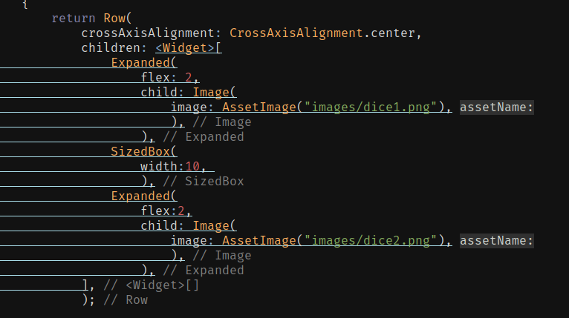
Whenever Widget or element or image is too big, fit to the screen,there will be overflow conditions, there are two ways to fit these widget into the screen,
- Setting the width of the image or Widget via Hard Coded Values. ❌
- Or use Exapnded class. ✅

Expanded Class
- Expanded changes the constraints (Width & Height) of a child widget, so it fills any empty space.

Image.Asset(“ STRING”)
- An optimal way to add the image , by Image.asset(“sample.jpeg”);
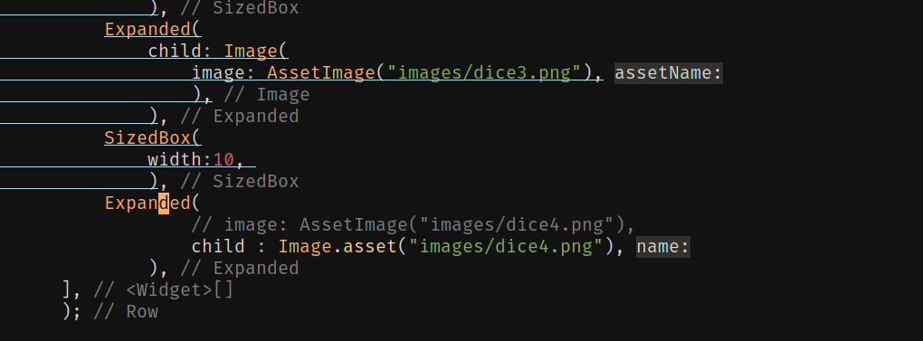

If the widget i.e constructor of the class does contains the padding named
argument in Parent Widget and if it is taking only child then assign it’s Child: a Padding( ) widget .

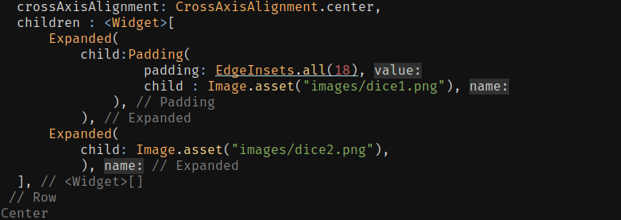

Gesture Detection In Flutter

Note :
String interpolation
Simply use any button in flutter for simple gesture direction in flutter.

🧠Stateless Widget &🧠 StatefulWidget
Intro
- States of the stateless widget are not meant to change.
- If you create the image which need to be change throughout the program based on the
interaction with the user, then statefulWidgets are best choice for making such embedding
such widgets in your root widget tree.

State :
- State is reffered to the way things are.
- If application havng the top bar, then the state of that application will never change, it will be same thtough out screens and user interactions of the user, then in that case use the StatelessWidget.

🔰 Creation of StatefulWidget

- For creating the StatefulWidget you gonna need two classes :
  - A user defined app class, extending the StatefulWidget.
  - A special class which will be keeping the track of State and if the state of the app changes then the it updates the screen of application.

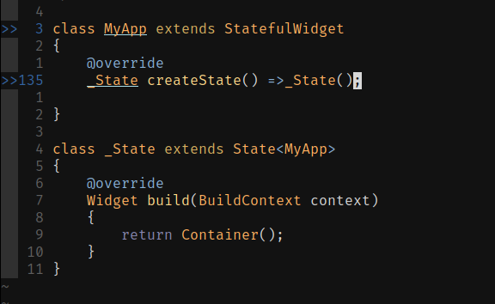
- There are two parts of the StatefulWidget
- First a Widget part (Class) which will calling the createState() method.

